11762 – 106 St.
Edmonton, AB T53 4Y7

April 13, 2020
……………………………
Instructor, ENGL1102
Northern Alberta Institute of Technology 11762 – 106 St.
Edmonton, AB T53 4Y7

Dear sir/madam:
“A Technical Description: Physical Features and Operation of the sump pump as well as its operating cycle. The report was authorized by you during week 7 of the ENGL1102 course.

The report is organized into three main sections: an introduction that provides a definition summarized description of the valve, a main body section that describes each major part in detail, and a conclusion that briefly describes the functional overview and operating cycle of the valve.
I would be more than happy to respond to any questions that you may have regarding the report. You can contact me by email at -----------------

Sincerely,

---------------
Mechanical Engineering
ENGL1102
Northern Alberta Institute of Technology
Edmonton Alberta

As a submission to
--------------------------
Prepared by ----------------

ENGL1102 Technical Description
Project Mechanical Engineering
Technology
November 20, 2020

Contents
1.0 INTRODUCTION 4
1.1 Definition and Purpose 4
1.2 Summarized Description 4
1.3 Background 4
1.4 List of Major Parts 5
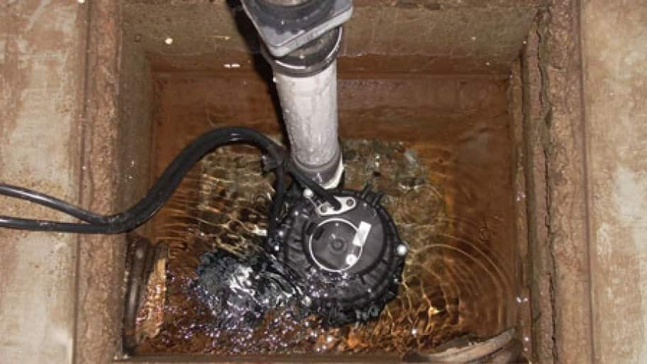 8
2.0 DESCRIPTION AND FUNCTIONS OF MAJOR PARTS 8
2.1 Motor 8
2.2impeller 8
2.3 discharge 9
2.4 discharge pipe 10
2.5 switches 11
2.6 check valve 12
3.0 CONCLUSION 12
3.1 Functional Overview 12
3.2 Operating cycle 13
4.0 REFFERENCES 14

1.0 INTRODUCTION

1.1 Definition and Purpose
It is a pump used to drain water that is stagnant in a water collecting basins or unwanted basements at home. The water may enter through the drainage systems of a building funneling into the water collecting basin. The water flood from rains or just natural ground water. Sump pumps are sometimes used in sewage treatments or disposal of water into the drainage systems.

1.2 Summarized Description
There are two types of sump pumps: pedestal pump. This pump is serviced more easily when the motor is above the sump and it is more visible. The impeller of the pump is driven by a long extension shaft and the impeller is at the bottom of the pump,
Submersible pump. Found inside the pump and it is usually sealed to prevent electrical short circuit. Pedestal sump pump has a long life of up to 25-30 years if well installed and kept off debris. They are cheaper and easier to remove. Submersible pump has a life of up to 15 years. They are expensive but do not clog upon taking up debris.

1.3 Background
Sump pump was invented back in the year 1946 by the U.S electrician, Karl Niedermeyer. The main reason for invention was to reduce the water accumulation on buildings foundation. This is possible by digging a sump pit which is dug at the lowest part of the building to give way for the excessive accumulating water. A sump pump is then installed to discharge the water once it is turned on through a discharge pipe to a drainage pipe ("Sump Pump QUESTIONS — Publications", 2020). The sump pump is automated in such a way that it turns itself on once the sump pit tank is full.

1.4 List of Major Parts
The lock-up torque converter comprises of the following parts
- Motor
- Impeller
- Discharge
- Discharge pipe
- Switches
- Check valve

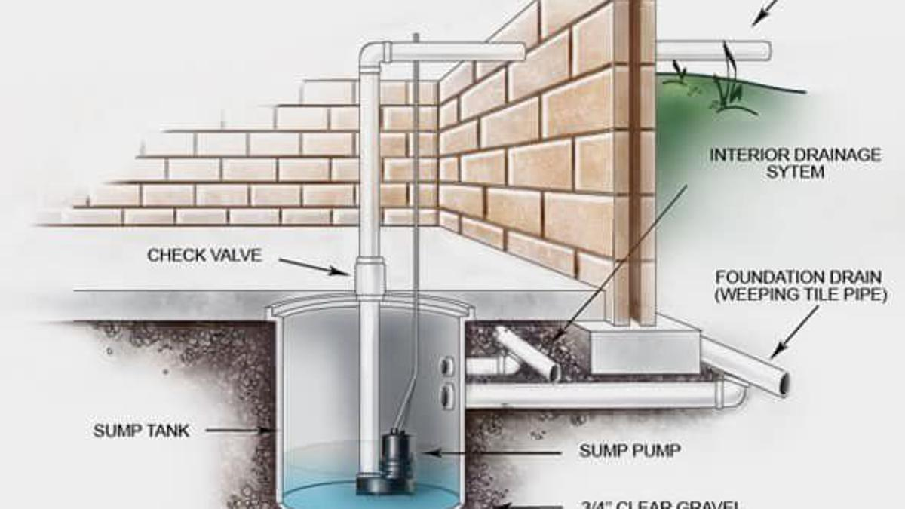
Figure 1 a sketch of a sump pump
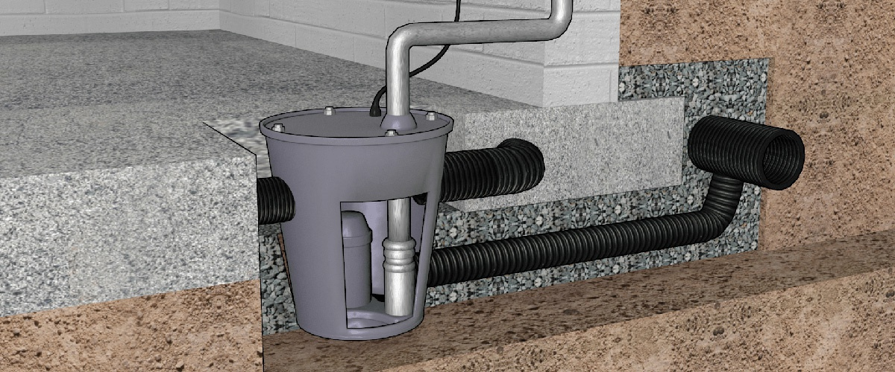
Figure 2 a sump pump cross sectional view

Figure 3 a sump pump in operation

2.0 DESCRIPTION AND FUNCTIONS OF MAJOR PARTS

2.1 Motor
Most sumps uses a centrifugal motor which pumps have a quarter to 1 hp which makes them capable of handling even worst flooding and water pressure without difficulty.

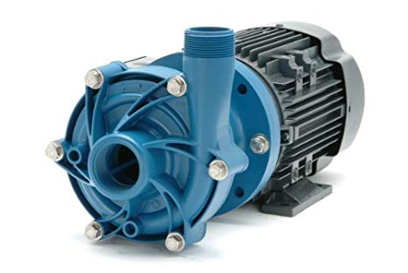
Figure 4 a sump pump motor

2.2impeller
A fan like structure that is attached to the motor assembly. It creates centrifugal force during its rotation that produces a low pressure region at the mouth of discharge ("Sump pump", 2020). This makes the water funneled into it and later to the discharge pipe
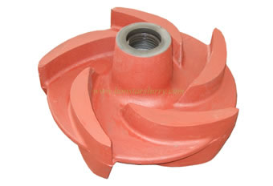 Figure 5 a sump pump impeller

2.3 discharge
It is a tube which is cylindrical shaped and open on both ends. Can be at sometimes cone shape at one edge and cylindrical shaped on the other edge. They help to funnel the water into the discharge pipe which in turn takes the water out of the pump.
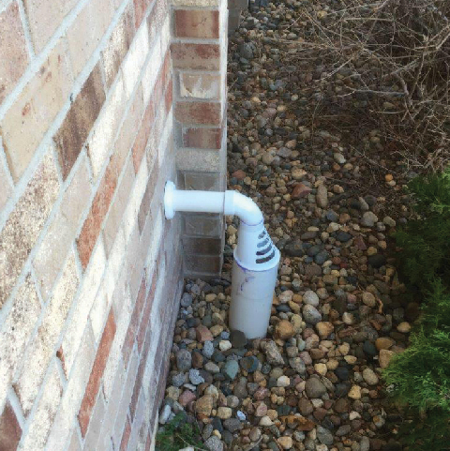
Figure 6 a discharge

2.4 discharge pipe
It may be a hose pipe, copper pipe or a PVC pipe. The most suitable type of discharge pipe is the PVC type due to its capability to withstand the corrosion and long lasting.
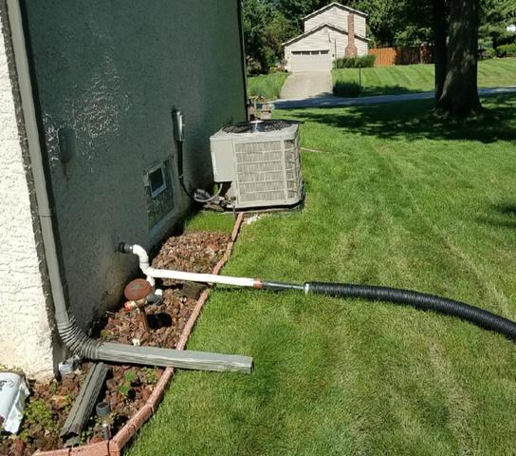
Figure 7 discharge pipes

2.5 switches
There are many types of switches but most common known is the float switch. Comprise of a plastic float attached to the switch. The float acts as the trigger for operating the switch. When the water pressure pushes the float up, the switch turns the motor on and the sump pump begins to remove the water
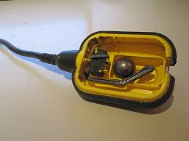
Figure 8 a float switch

2.6 check valve
It can be placed in the discharge or in the water inlet. In case the sump pump which is automated, once the water has been pushed out and the motor stops, some water remains in the pipes which can flow back into the pump causing malfunctioning of the pump. Check valve is used in blocking the return of the water into the motor.
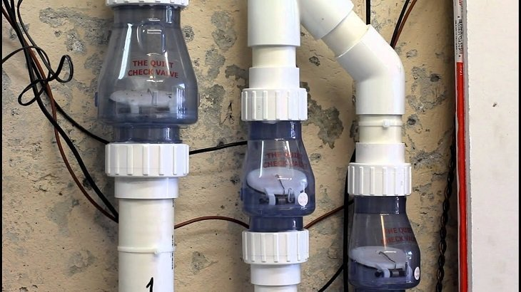
Figure 9 check valves

3.0 CONCLUSION

3.1 Functional Overview
A sump pump is a very important thing to have in a home or an industry. It helps reduce stagnation of dirty water which might in the end cause diseases to people. It also helps prevent buildings from weathering off as water is a great agent of weathering off of buildings. It also helps reduce the ground water and proper disposal of rain water to keep surfaces dry thus prevention of bacterial infections.

3.2 Operating cycle
a sump pit is found in a basement’s lowest part. The pump is the turned on by the act of the pit being filled with water. The building must have pipes through which the liquid moves from the building to far away from the foundation. At the end of the pump there is one way valve called a check valve. It helps to prevent from draining back into the pit. A pressure sensor or a float activator enables the sump pump to start automatically. Water exacts more force on the sensor. Air exacts less force. An air filled ball floats and it moves the arm as water increases. A centrifugal pump is used by a sump to move the water. Water is moved to the idea of the pump by an impeller which acts when the motor is on. A low pressure area is created at the center. The void is then filled with water from the pit and as the impeller spins water is pushed out.

4.0 References
Sump pump. Academic Dictionaries and Encyclopedias. (2020). Retrieved 20 November 2020,
from https://enacademic.com/dic.nsf/enwiki/729955/Sump_pump.

Find information about sump pumps. Plumbingmart.com. (2020). Retrieved 20 November 2020,
from http://www.plumbingmart.com/sump-pump-information.html.
Sump Pump QUESTIONS — Publications. Ag.ndsu.edu. (2020). Retrieved 20 November 2020,
from https://www.ag.ndsu.edu/publications/home-farm/sump-pump-questions.

